MODULE 4 – INTRODUCTION TO DBMS

LAB EXERCISES

19. Introduction To PL / SQL
Lab 1.
Write a PL / SQL block into a new book into the books table and display a confirmation message.
Ans.
1. DELIMITER //

CREATE PROCEDURE inert_new_book()

BEGIN

INSERT INTO books (book_id, title, author, publisher, year_of_publication, price) VALUES (9, 'Data strcutures', 'mark ben', 'MG Grill', 2017, 120);

SELECT 'Book inserted successfully' AS Message;

END//

DELIMITER ;
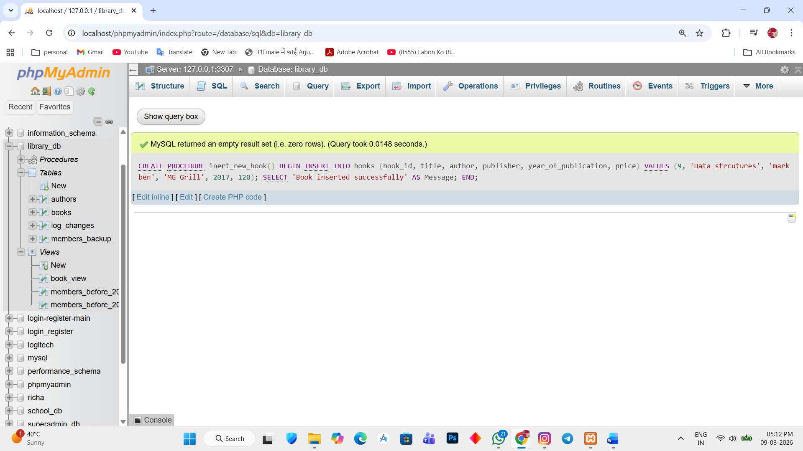

INSERT INTO books (book_id, title, author, publisher, year_of_publication, price)
VALUES (10, 'Computer Graphics', 'John Smith', 'Pearson', 2019, 150);
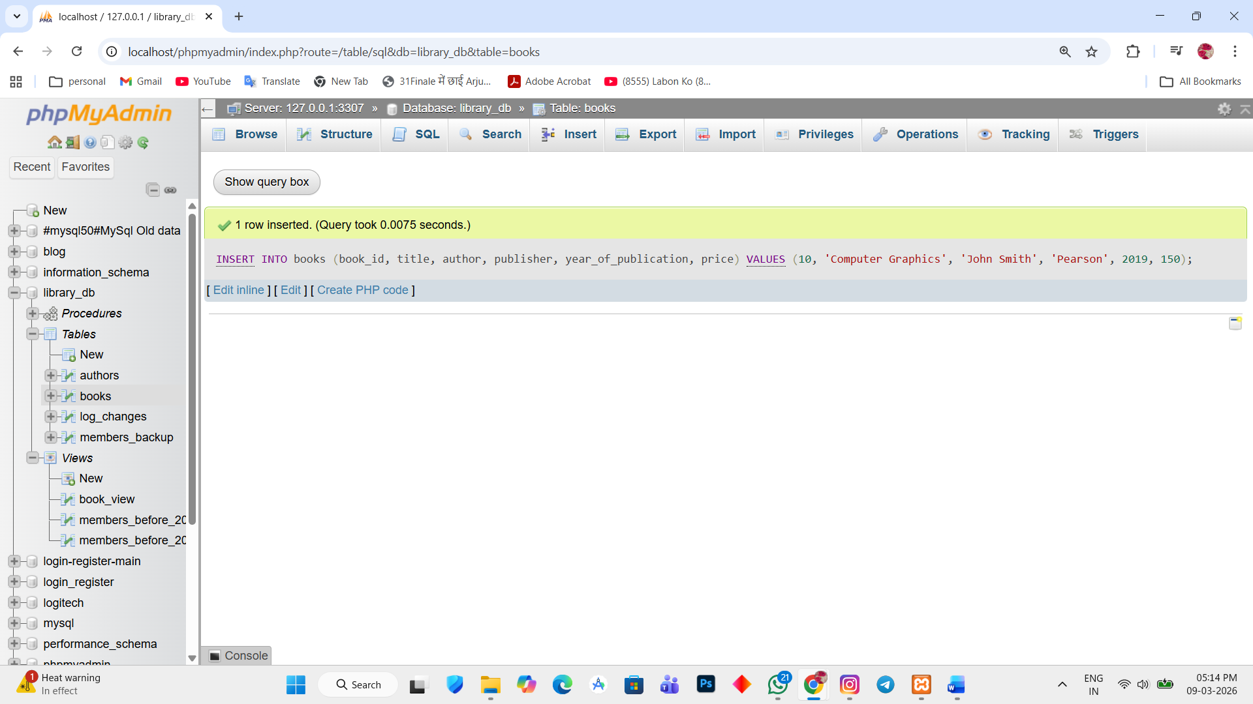

Final message print when new record inserted.
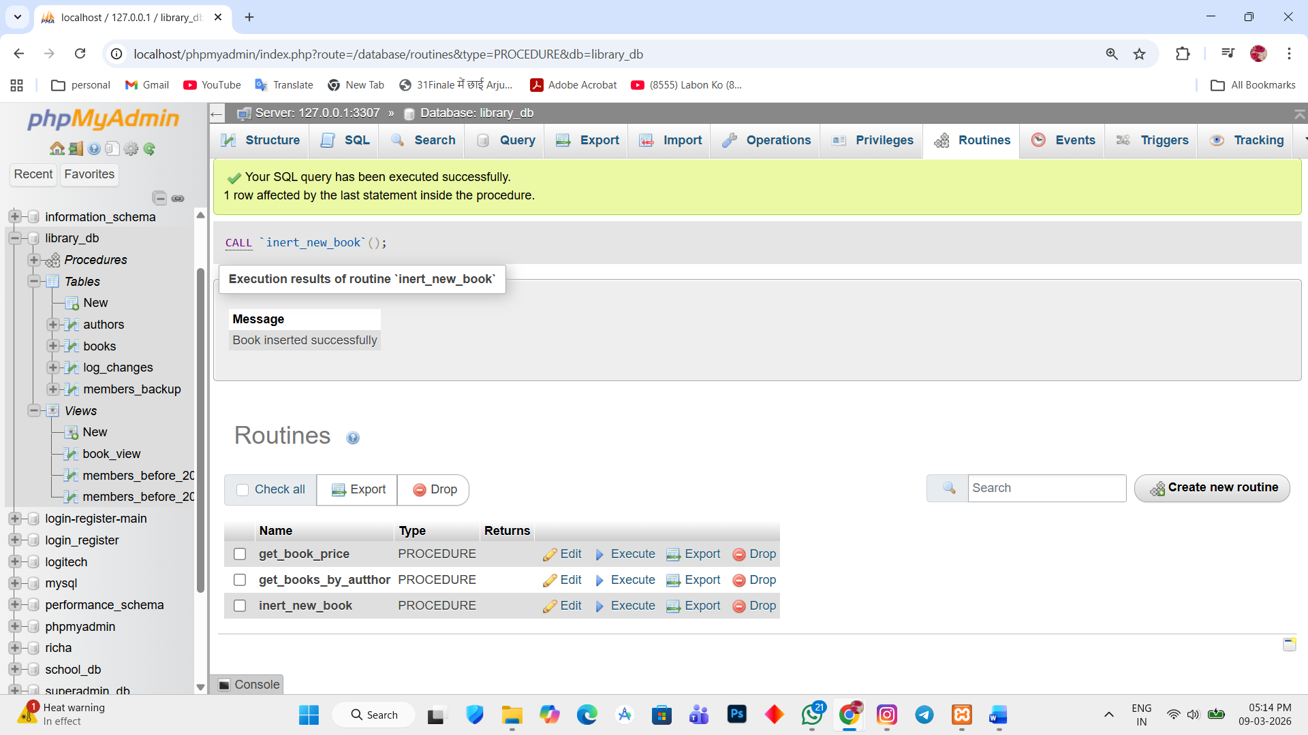

Lab 2.
Write a PL / SQL block to display the total number of books in the books table.
Ans.
1. DELIMITER //

CREATE PROCEDURE total_books()

BEGIN

DECLARE total int;

SELECT COUNT(*) INTO total FROM books;

SELECT total AS total_number_of_books;

END //

DELIMITER ;
